**Problem 2**

[**The Weeds among the Corn**](javascript:OpenSupp('exercise','21',17)) is completely randomized experiment. Two treatments—one weed per meter and nine weeds per meter—were assigned completely at random to eight plots of land. Each was assigned to four plots. Here are the yields of corn (bushels per acre):

http://macmillanhighered.com/BrainHoney/Resource/6710/ebooks.bfwpub.com/bps7e/tables/21_T_UN_17.gif

Explain why you decided that two-sample *t* procedures probably may not be accurate. However, the permutation test can be used. The display below shows the distribution of all possible mean differences for the 70 different ways treatments could be assigned to plots. Use the display below to estimate the *P*-value of these data. (4 pts each)

The observed means are http://macmillanhighered.com/BrainHoney/Resource/6710/ebooks.bfwpub.com/bps7e/pics/ans_ineqn741-14.jpgand http://macmillanhighered.com/BrainHoney/Resource/6710/ebooks.bfwpub.com/bps7e/pics/ans_ineqn741-15.jpg. The observed difference in means is 5.225. From [**Figure 21.6**](javascript:OpenSupp('figure','21',6)), the one-sided *P*-value is about 0.06 + 0.11 + 0.04 + 0.04 = 0.25. We have no evidence that an increase in weeds from one per meter to nine per meter decreases the crop yield.

[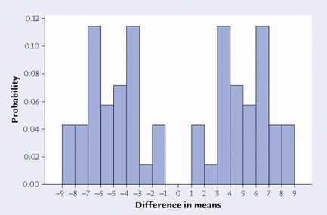](javascript:OpenSupp('figure',21,'6'))

Use R and as a test statistic use the mean of Nine weeds/meter in order to test a one sided hypothesis. (16 points)